**Salesforce Lead & Enrollment Entry Training Guide**

**Production:** [Salesforce PROD](https://curanahealth.my.salesforce.com/) This is the link to the production environment

**Support Email:** [salesforcesupport@curanahealth.com](mailto:salesforcesupport@curanahealth.com) Please send any questions or concerns to this email address

**Key**

**Application Types**

1. **Electronic – in-person enrollment, applicant selects ‘I agree’ check box**
2. **Paper – enrollment via paper form, must upload original form**
3. **Plan Website – enrollment via plan website, must upload original website produced document**
4. **Telephonic – enrollment via recorded phone line**

**Disposition Types**

1. **PTC – populates when PTC checkbox is checked**
2. **SOA – Opens SOA and Application tabs**
3. **SOA Submit – Triggers SOA field validation rules**
4. **Application in Progress – Triggers Application validation rules**
5. **Application Completed – Flags Process as completed is triggered by selection of the “Submit” button**
   1. **DO NOT manually update to this disposition**

This guide provides step-by-step instructions for agents to create a new Lead in Salesforce. Follow the steps below and refer to the placeholders to insert screenshots for clarity.

## Step 1: Navigate to Leads

1. On the top left of the screen, next to the Health Plan Enrollment Tab, locate the dropdown box with different tab options.  
2. Select 'Leads' from the dropdown.  
3. A list view of all your leads will appear. Please be sure to always use the list view for the initial search and not the intelligence view. The list view allows you to create a unique view for yourself and save it. At the end of the document the steps to create a unique view are listed.

## Step 2: Create a New Lead

1. On the top right side of the screen, you will see several buttons: New, Intelligence View, Import, Add to a Campaign, Change Status.  
   2. Click the 'New' button.
2. A new page will display where you can begin entering the required lead field information.
   1. These include:
      1. First Name
      2. Last Name
      3. Lead Source - Picklist
      4. Initial HP – Lookup
      5. Select a Facility – Lookup
      6. Who makes the decision for the beneficiary? - Dropdown
3. Once all required and additional fields have been completed, click 'Save' located at the bottom right of the screen.
4. The record will be saved and will bring up the new lead page.

## Step 3: Complete Additional Information

1. On the new lead page, you can enter additional information as needed.
2. Two important items to be done on this screen are:
   1. You must do the zip to county validation of the health plan. To do this you enter the member’s zip into the field labeled **“Zip” in the Zip to County box on the far-right hand side of the page.**
      1. Once entered click on “Next”
      2. The value in the field will change from zip to county name. There could be more than one county so select the drop down next to the county and if more than one value is present, click on the correct county. Once the county is selected (if there is only one county listed, it is considered selected) you click next again.
      3. At this point, you will see a list of plans show up in the field. Choose the appropriate plan and then click save.
      4. This action does the following
         1. Moves the plan information to the Health Plan field of the Health Plan/ Facility Information box directly below.
         2. Stores the county in the member’s county field to the left of the page
   2. This screen also contains the PTC field which you will check when you have the PTC. Selecting this box will change the record’s disposition to “PTC”.

## Step 4: Dispositions

1. Dispositions work much the same as they did in Evolve but Salesforce also uses them as triggers to control workflow. Examples of this workflow process include:
   1. PTC – populates when PTC checkbox is checked
   2. SOA – Opens SOA and Application tabs
   3. SOA Submit – Triggers SOA field validation rules
   4. Application in Progress – Triggers Application validation rules
   5. Application Completed – Flags Process as completed is triggered by selection of the “Submit” button

## Step 5: Create the SOA - SOA Tab

## Change the Disposition “SOA”.

1. Enter all required fields into the SOA screen. Many fields will flow over automatically if they were entered on the lead details page.
2. When all the required fields have been populated, change the Disposition to “SOA Submit”.
3. This will validate that all required fields have been populated.
4. Click the blue “SOA” button at the top of the screen over the right column.
5. The form will be created and displayed under files. It will be named with the lead name and SOA.
   1. The system can be slow in displaying the file. You may have to click the refresh button a couple of times before it appears.
6. If you double-click the link to the file, you will be offered the opportunity to review and download the file.

## Step 6: Create the Application - Application Tab

1. Make sure that all required fields are saved. If you miss any required fields, the record will not be saved and you will see red boxes indicating what fields are required.
2. Change the Disposition to Application in Progress.
3. Once it has saved, click the blue button labeled Application next to the SOA button.
4. The form will be created and displayed under files. It will be named with the lead name and Application.
   1. The system can be slow in displaying the file. You may have to click the refresh button a couple of times before it appears.
5. Follow the same process as you did with the SOA – double click the file name and the record will display, and you will have the ability to download the file.

## Step 7: Application Submission

## There are three separate submission processes. One for paper application and plan website types, one for telephonic, and one for electronic.

**Telephonic Application Type**

* 1. Once you have completed the application process and chosen Telephonic as the application type, you will click on the green submit button at the top of the left-hand column.
  2. This action does two things. It sends the application record to the process that creates the file for submission to QNXT.
  3. It changes the record disposition to “Application Completed”.

**Electronic Application Type**

1. Once you have completed the application process and chosen Electronic as the application type, you will see several new fields displayed for the purpose of allowing the applicant to attest to the selection of the plan displayed on the application.

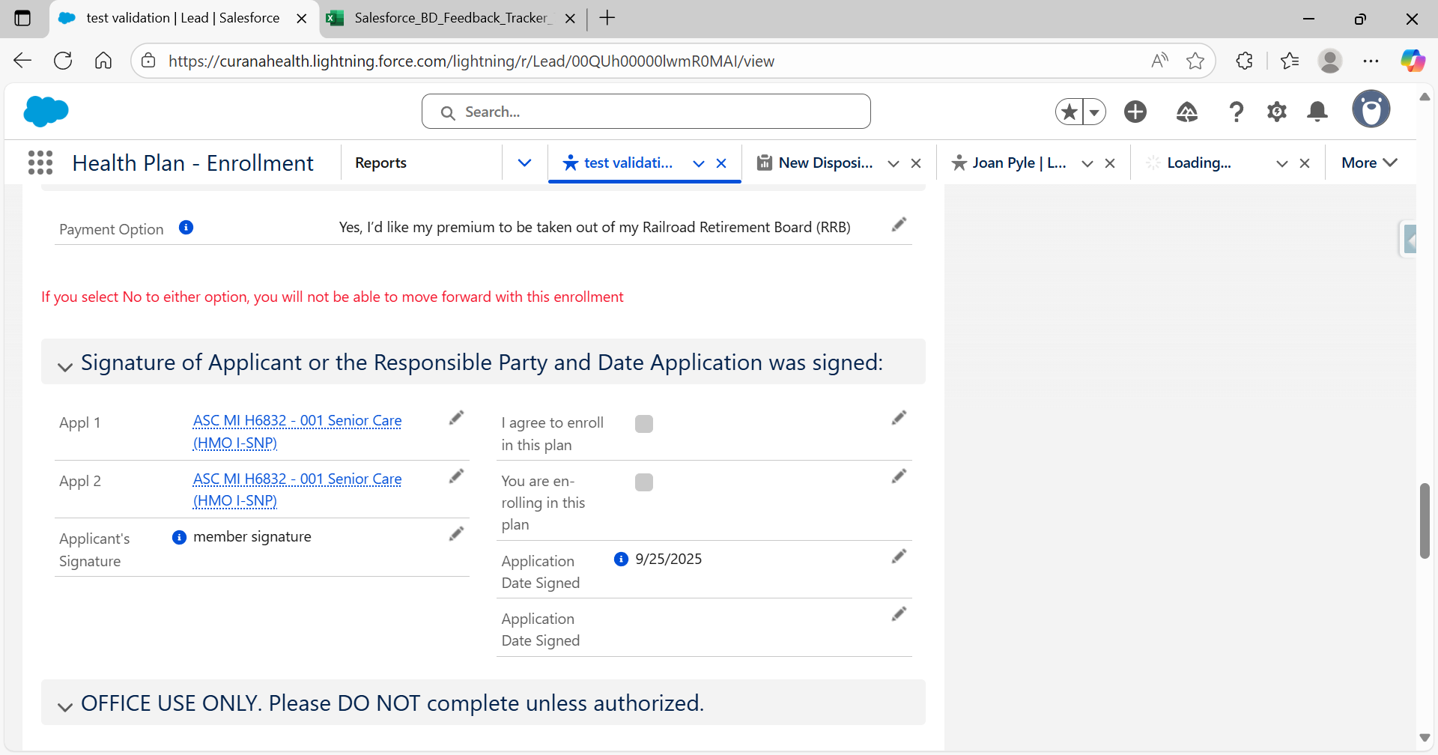

1. You will see the red text above the applicant signature section indicating that both checkboxes below must be checked for the enrollment to proceed.
2. There are two new fields called Appl 1 and Appl 2. Both fields contain the name of the plan that the applicant has selected. They refer directly to the two checkboxes.
3. Checking both boxes will allow the process to continue, but if the applicant does not agree with the question, the application will not save as Application Completed, it will move to the Application Incomplete.

**Paper and Plan Website Application Types**

1. Once you have completed the application process for these application types, you will see 2 new fields displayed under the “Enroll Year” field. They are “Paper Application Uploaded” - Yes or No and “Paper Application Rejected Reason”.
2. You must upload the paper application into the files section on the right-hand side of the screen where your application and SOA files are located.
   1. To upload the application, click on the down arrow across from the section name “Files” and you will get the option to add files.
   2. A box will come up giving you the option to choose the file you want to upload.
   3. Select the correct file name and click add.
   4. The file will be displayed in the files list.
   5. Then you can click yes in the field called “Paper Application Uploaded “.
3. Next you will see a button at the top of the left-hand column called “Validate”.
4. Click this button and the record will be routed to the admin team for review.
5. The admin team has the option to either submit or reject the application after their review.
   1. Submitting the application finalizes the process and changes the Disposition to “Application Completed”.
   2. Rejecting the application routes the record back to the agent.
      1. You should receive an email when the app is rejected.
      2. Go to the main leads tab and select the view of “Rejected Apps”.
      3. This view will allow you to click on the link and return to the application.
      4. The “Paper Application Rejected Reason” field will be populated with a description of the error found.
      5. Once you correct the error, you can click the “Validate” button again and the app will route to the admin team again.
      6. If the admin team finds the application entry is correct, they will submit it, and the process is complete.
      7. If an error is still found, the admin team will reject it, and the process will start again until a clean application record is completed.

## Steps to create a Unique List View (Preferred Lead View)

* Directly under the bar where you selected list view you will see another bar and, on that bar, there is a picture of a gear
* Click that gear and select New.
* A box will pop up and you can enter a view name – something like My Lead View that you will recognize.
* You do not need to enter the List API Name; the system will do that based off of what you name the view.
* Then select either “Only I can see this list view”
* After you save the view name, go back to the gear and choose the option “Select fields to display”.
* There will be two boxes showing. The one on the left are fields that are available to display and on the right are fields that are currently displaying.
* You can use the arrow keys between the boxes to make your selections. You can remove fields in the current displayed fields by highlighting the field and clicking the left pointing arrow. Using the right pointing arrow will allow you to highlight and add fields from the left box to the displayed fields in the right box.
* Once your selections are made, save the view.
* This returns you to the main screen where you will see on the far right a box called “Filters”. Simply click the “X” across from the Filter label and the box will go away.
* Your new view will be the view you now see. If you are happy with this new view, go up to the thumbtack next to the name of your view and click. The thumbtack will change from leaning and now be straight. This means you have pinned the view, and it will be your default view.